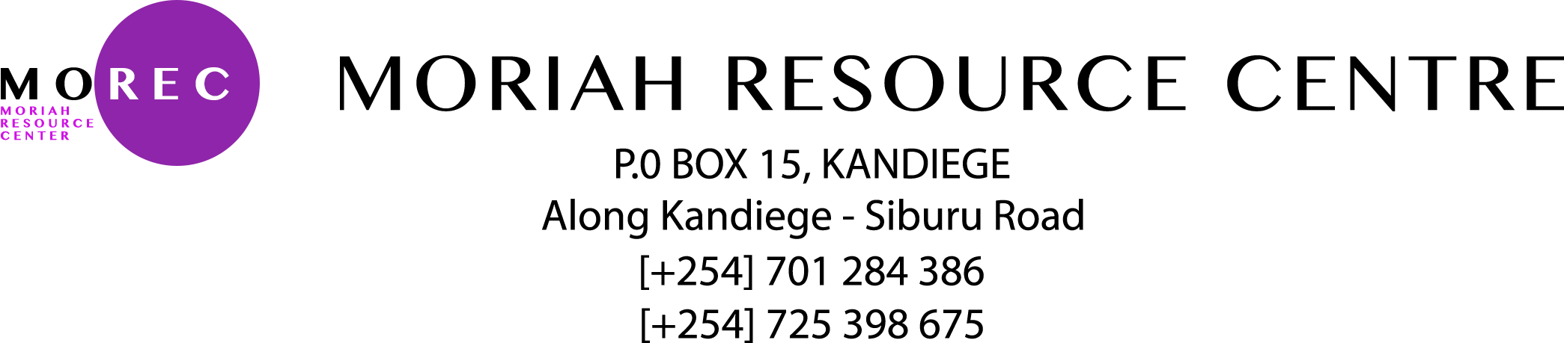

MOREC COURSES AND SERVICES
MOREC offers the following services
Computer packages Training and certifications:
Course | Duration | Cost (Ksh.)
Microsoft office word | 1 week | 300
Microsoft Excel | 1 week | 300
Microsoft Access | 2 weeks | 400
Microsoft Power Point | 1 week | 300
Corel Draw & Designs | 2 weeks | 400
Microsoft publisher | 1 week | 300
Internet and Browsing | 1 week | 300
Microsoft Outlook | 1 week | 300
Microsoft Windows | 1 week | 300

COURSES | DESCRIPTION
Basics in hardware Maintenance | Hardware maintenance and troubleshooting of computer hardware,printers,scanners,laptops and desktops.
Basics in Website Designs and Template Creations | Creation of content management systems such as individual portfolios, schools and organizations
IT Training services outsourcing. | MOREC provides a conducive environment for the ICT related programs training ie Google youth empowerment program, NGO’ trainings
Data Entry Services | MOREC provides data entry programs to NGO,CBO,CHVs both locally and Nationally
Examinations Printing | Most schools in the county prefer MOREC for the Exam printing programs especially the surrounding schools
Concepts of Software Program | Installations of software  Basics in computer programming

